Periodontal surgery
Part 1 Dr.Huda Jasim Jebur
Introduction:
The decision about what type of periodontal surgery should be performed and how many sites should be included is usually made after the effect of initial cause-related measures has been evaluated. The time lapse between termination of the initial cause-related phase of therapy and this evaluation may vary from 1 to 6 months.
- The successful cause related therapy depends on:
1-Removal of calculus and bacterial plaque will eliminate or reduce the inflammatory cell infiltrate in the gingiva.
2-Reduction of gingival inflammation makes the soft tissues more fibrous and thus firmer, which facilitates surgical handling of the soft tissues, the bleeding is reduced, making inspection of the surgical field easier.
3-A proper assessment of the prognosis has been established by the effectiveness of the patient’s home care, Lack of effective self-performed infection control will often mean that the patient should be excluded from surgical treatment.

- Objectives of surgical treatment:
1-Creating accessibility for proper professional scaling and root planning.
2-Establishing a gingival morphology which facilitates the patient’s self-performed infection control.
3-Regeneration of periodontal attachment lost due to destructive disease.
4-Reduction or elimination of plaque retentive area especially periodontal pockets that have not responded to initial therapy.
5-Eliminate inflamed periodontal tissue example exudates, hemorrhage, suppuration that means to stop progression of disease process.
6-Correct mucogingival defect and improved periodontal esthetic.
7-Provide access to correct bony defect.

- Indications for surgical treatment
1-Impaired access for scaling and root planning due to presence of certain impeding factors as a wide tooth surface, root fissures, root furrows & furcation involvement. These factors may make even a shallow pocket demanding a surgical access gaining.
2-Impaired access for self-performed plaque control such as gingival hyperplasia or crater.
3-Correction of gross gingival abnormalities (for esthetic reason).
4-Shifting of gingival margin apically to a plaque retaining restoration.
5-To facilitate a proper restorative therapy.

- Instruments used in periodontal surgery
- The instrument tray:
1-Mouth mirrors and graduated periodontal probe/explorer.
2-Handles for disposable surgical blades:
-Bard-Parker handle (ordinary handle).
-Blacks handle with screw key (special handle).
3-Mucoperiosteal elevator and tissue retractor.
4-Scalers and curettes.
5- Cotton pliers and tissue pliers.
6-Tissue scissors, suture scissors and Needle holder.
7-Burs.
8-Plastic instrument.
9- Hemostat.

- Additional equipment:
1-Syringe for local anesthesia and syringe for irrigation.
2- Aspirator tip.
3- Physiologic saline.
4-Surgical gloves and mask, surgeon’s hood and Draping for the patient.

- The characteristic oozing type of bleeding can be controlled by a pressure pack (sterile gauze moistened with saline). Bleeding from small vessels can be stopped by a hemostat and resorbable sutures.
- Sterile physiologic saline is used for rinsing and moistening the field of operation and for cooling when burs are employed. The application of saline to the wound by means of a sterile disposable plastic syringe and a needle with a blunt tip.
- Visibility in the field of operation is secured by using effective suction.

- Surgical instruments:
Knives:
- Fixed blade: The advantage (can be given any desired shape and orientation in relation to the handle), while disadvantage (needs resharpening).
- Replaceable blade: The advantage (sharp and can be replaced rapidly), while disadvantage (cutting edge follows the long axis of handle which limit their use).

- Disposable blade when mounted in ordinary handles (Bard-Parker), they are used for releasing incisions in flap operations, mucogingival surgery and for reverse bevel incisions where access is obtainable, but when it mounted in Special handles make it possible to mount blades in any angulated positions, which facilitate the use of such knives for both: gingivectomy excisions and reverse bevel incisions.

Scalers and curettes:
Scaling and root planing in conjunction with periodontal surgery take place on exposed root surfaces. Access to the root for debridement may be obtained with the use of comparatively sturdy instruments. Tungsten carbide curettes and scalers with durable cutting edges are often used when “access” is not a problem.
Surgical burs:
The burs should operate at low speed and rinsing with sterile physiologic saline should ensure cooling and removal of tissue remnants. Rotating fine-grained diamond stones may be used within infrabony pockets, root concavities, and entrances to furcations. The round burs are used for bone recontouring.
Instruments for bone removal:
Sharp bone chisels or bone rongeurs cause the least tissue damage and should be employed whenever access permits. With reduced access, surgical burs or files may be used for bone recontouring.

- Types of periodontal surgery

1-Gingivectomy & Gingivoplasty procedures:

The surgical approach as an alternative to subgingival scaling for pocket therapy was already recognized by Robicsek (1884). Later defined by Grant et al. (1979) as “the excision of the soft tissue wall of a pathologic periodontal pocket”. The surgical procedure, which aimed at “pocket elimination”, was usually combined with recontouring of the diseased gingiva to restore physiologic form. While, the gingivoplasty is the minor alterations in the gingival morphology.

Robicsek and, later, Zentler described the gingivectomy procedure in the following way.
-The straight incision technique (Robicsek 1884).
-The scalloped incision technique (Zentler 1918).

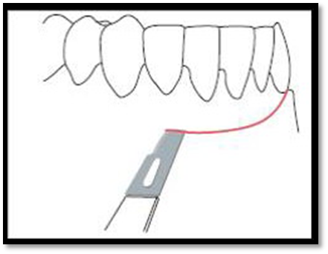
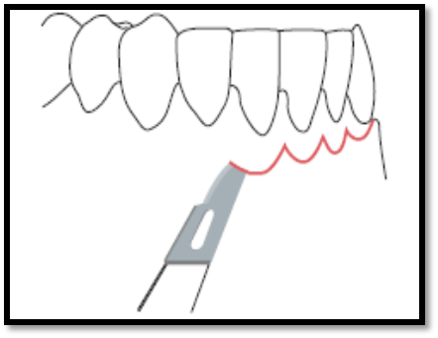

Gingivectomy may be performed for the following indications
1- Elimination of suprabony pockets if the pocket wall is fibrous and firm.
2-Elimination of gingival enlargements.
Contraindications to gingivectomy include the following:
1- Access to bone required.
2-Narrow zone of keratinized tissue.
3- Aesthetics.
4- Patients with high postoperative risk of bleeding.

Disadvantage:
1-Gross wound post-operative pain.
2-Healing by secondary intention.
3-Danger of exposing bone.
4-Loss of attached gingiva.
5- Esthetic problem in the anterior area with sensitivity due to exposure cervical area of the tooth.
Technique:
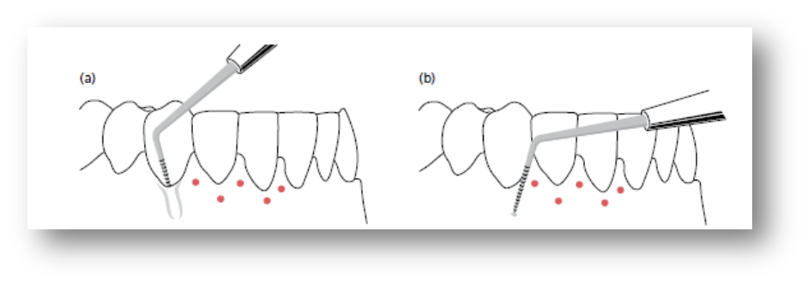
It was described in 1951 by Goldman. When dentition in the area indicated for surgery has been properly anesthetized, the depths of the pathological pockets are identified with a conventional periodontal probe. At the level of the bottom of the pocket, the gingiva is pierced with the probe and a bleeding point is produced on the outer surface of the soft tissue. The series of bleeding points produced describes the depth of the pockets at several location points around each tooth in the area indicated for treatment and is used as a guideline for the incision.

The primary incision, which may be made by a scalpel blade (No. 12B or 15) in either a Bard-Parker handle or an angulated handle (e.g. a Blake’s handle), or a Kirkland knife No. 15/16, should be planned to give a thin and properly festooned margin of the remaining gingiva. Thus, in areas where the gingiva is bulky, the incision must be placed at a level more apical to the level of the bleeding points than in areas with a thin gingiva. In areas where the interdental pockets are deeper than the buccal or lingual pockets, additional amounts of buccal and/or lingual (palatal) gingiva must be removed in order to establish a “physiologic” contour of gingival margin.

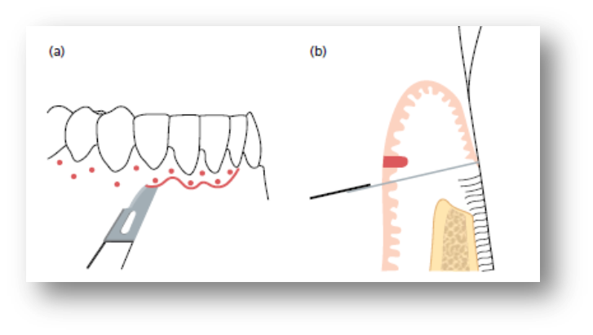
The interproximal soft tissue is separated from the interdental periodontium by a secondary incision using an Orban knife (No. 1 or 2) or a Waerhaug knife. The incised tissues are carefully removed by means of a curette or a scaler, Pieces of gauze packs often have to be placed in the interdental areas to control bleeding. When the field of operation is properly prepared, the exposed root surfaces are carefully scaled and planned.

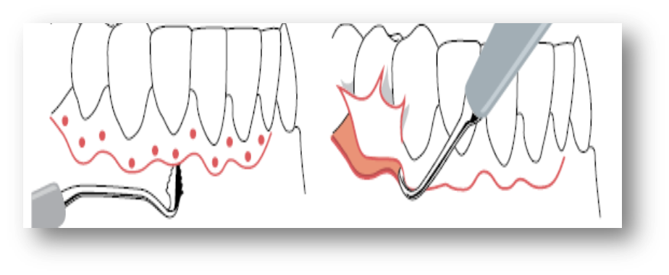
The gingival contour is checked and, if necessary, corrected by means of knives or rotating diamond burs.
To protect the incised area during the period of healing, it must be covered by a periodontal dressing. The dressing should be closely adapted and not bulky, since this is not only uncomfortable for the patient, but also facilitates dislodgement of the dressing.
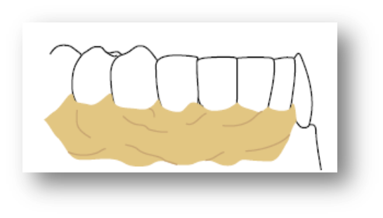
The dressing should remain in position for 10–14 days. After removal of the dressing, the teeth must be cleaned and polished.

"The purpose of our lives is to be happy."
-Dalai Lama

